Class 1: 2023-01-25
Let’s make phishing website url

Three elements of building a webpage: HTML, CSS, JS.

Class 2: 2023-01-26
Learning HTML:

Check MyFirstPage folder in Internet-Programming-2023(Desktop) to see the first webpage I made.

All numbers are in pixels
height = 55 = height=55px
Text is always in double brackets
<IMG src = “image2.jpeg”>
<IMG src = “image2.jpeg” height=55 width=55>

Page 17: on slides

Class 3: 2023-02-01
FORMS:

<form action = “server.php“ method = “Post”> (action keyword is where it sends the information)
</form>

“Input” keyword defines how it’s going to be portrayed on the page. Here are the different types of input. (<input type = “[...]”)
Input Type
(DEFAULT) Text
Password
Radio
Checkbox
Submit
Button

Methods:
Get (DEFAULT)
It shows the sent information through the search bar. Use this when you want everyone to see the information. It has a restriction of 512 characters because of the URL.
Post
Same thing but hidden from the naked eye. Use this when there is a lot of information or if you don’t want everyone to see the information. It doesn’t have any restrictions, it just packs it up and sends it away. You need to use, method = “Post”, to use post, the method keyword is essential.

Class 4: 2023-02-02

We can make dropdown lists by using <select><option>Food</option></select>.
To make us able to click multiple options in a dropdown list, we add the keyword, “multiple”, in select and when we click control, we can choose multiple options. (<select name = "age" multiple><option></option></select>)

<div></div> is an element that's used everywhere but does nothing, it is just for readability and logic to group things together, all titles + subtitles grouped together, paragraphs grouped together, image and caption grouped together all wrapped around the blanket of div.

div
h3
H5
/div
div
P
/div
div
img
Caption
/div

div
h3
h5
p
img
Caption

Div is like inheritance, by itself it’s useless, when combined with css + js, let’s say you want to make the text red, you just do it in the div instead of each thing separately.
Reminder:
Three elements of building a webpage: HTML, CSS, JS.

Basic HTML: COMPLETED! DONE!

Class 5: 2023-02-08
Joker can represent any other cards, it's a wild card, same thing with “*” it represent a wild card
CSS!!!
Style sheet

Border = box
Padding = bubble wrap
Content = items
Margin = space outside box

padding: 25 15 15 15px; its like a clock first is top then right then bottom then left
Padding: 25 15px;
Padding: 15px;

In padding: providing two numbers just means it'll copy those two for the next two numbers, it repeats it so an easy shortcut. You can also do it with 1 number and it repeats itself 4 times, they are the same number. DOESN’T WORK WITH 3 NUMBERS, Its not a rule or exception so it varies what happens from browser to browser.

SAME THING APPLIES TO MARGIN.

Div.wrapper
Or
.wrapper{ // wrapper is class name
}

Absolute = based on browser
Fixed = based on browser but doesnt move
Static = acts what is expected to act, it stays inside its container, it looks where its supposed to be where nothing else is going on and that its starting point to figure out how much it needs to move

Class 6: 2023-02-15

HTML 5

HTML 5 is the new and improved upgraded version of normal HTML. It introduces a lot of new elements in which to help reduce the amount of “<div>” we normally have. It just reduces the use of <div>.

NEW COMMANDS: They are VERY obvious to what they think they do:

<header></header> = appears at the top of the site → Additional information at the start of the page
<footer></footer> = appears of the bottom of the site → Final closing information at the end of page
<nav></nav> = used for navigating menus and creating menus → intent is to lead me across other pages of the website
<article></article> = used to represent content
<aside></aside> = used for creating panels on right hand side of page
<section></section> = used for groups of related information. It’s for sections, it’s exactly as what you would think it would be
<hgroup></hgroup> = used to group together a set of one or more <h1> through <h6> elements
<figure></figure> = used to group together images and other stuff related like captions
<figcaption></figcaption> = used for captions of figures
Eg:
<figure>
<IMG src [....]>
<figcaption></figcaption>
</figure>

DO NOT USE THE WRONG ELEMENTS → THEY ALL WORK AS <div> BUT IT’S TO HELP US FOR READABILITY.

For Lab Tomorrow:
Set Margin auto

HTML MEDIA

Multimedia elements like audio or video are stored in media files. You must learn the different formats by looking at their extensions: swf (adobe flash), .flv(flash) .mp4 (video), .wav (audio), .mp3(audio), .avi (video), .wmv (video), mov (video)etc.

<video></video> = specifies a standard way to embed a video in a webpage
<audio></audio> = specifies a standard way to embed an audio in a webpages

Eg: video
<video width = “320” height = “420” controls> //controls allow you to have playbar (ability to pause, fast forward, rewind
<source src = “movie.mp4” type=”video/mp4”>
<source src = “movie.ogg” type = “video/ogg”> // fail safe if mp4 doesnt work
Your browser does not support the video tag. //final exception handling to let user know
</video>

Eg: audio
<video controls> //controls allow you to have playbar (ability to pause, fast forward, rewind
<source src = “horse.mp3” type=”video/mpeg”>
<source src = “horse.ogg” type = “audio/ogg”> // fail safe if mp4 doesnt work
Your browser does not support the audio tag. //final exception handling to let user know
</video>

“.” = Class
“#” = ID
“:hover” = when your mouse hovers the elements
“section.courses” = only sections with the classes courses

Absolute Path: The starting point possible so usually starts with hard-drive letter

Path: Sequence / order of directories and folders that leads us to the directory or file we want to go to
Eg:
drive:\folder{\folder}””
<img src = “C:\Users\ariel\Downloads\Yoko\Yoko\images\header.jpg”>
AVOID ABSOLUTE PATHS BECAUSE IT'S NOT THE SAME FOR EVERY COMPUTER AND IF U SWITCH TO SERVER IT WONT BE THE SAME

Relative Path: Step by step instructions to get to my final but the starting point is current place and not drive

<img src = "../images/header.jpg">
<img src = "images/header.jpg">

“..” means go back one level in case the main html is in a subfolder

Class 2023-02-22:
JavaScript → most desirable programming language in the world
Forms of JS → NodeJS, jquery, angular

JS can only be placed in <head>, <body> or separate file of html

Always write the JS code in the JS file never in the same file as html and we are going to link that file in the <head>. However there are some exceptions, for example, if we put script in <head>, it loads first, if we put it in the body, it loads after the <head> and everything on top of it. Code runs sequentially, JS is no different.

Java and C# are Strongly Typed Language HOWEVER JS is a Loosely Typed Language → eg:
var myVar = “Hello”;
myVar = 25;
myVar = myVar + 6;
myVar = true;

OUTPUT: 31
Since JS is a loosely typed language, it literally switches data types without ever having to care what the data type is. You don’t even need to have semicolons(:) at the end and it’ll work, however if you do, that’s horrible programming habits and will get automatic zero because of (Minification).

Concatenation: The process of fusing / merging / appending strings with other strings or data types.

Minification: The process of shortening normal code in order for it to be smaller and less big (in terms of file size) by removing all spaces and squeezing all code into few sentences in exchange for horrible readability. You can do this with automated websites / apps that convert your code.

<body onload = “popup();”> </body> → onload keyword is to first finish loading before the popup event gets called. It guarantees that everything was loaded before the popup() function gets executed and causes a popup.

DOM (Tree)

ID should be unique whilst Class can be shared by a lot. →
You can search for things in the Console tab of the Inspect Element of your page by writing: document.getElementById("myId")
<label id=​"myId">​Label​</label>​
and as you can see it shows me myId Label. You can do the same with classes with getElementsByClassName but classes can be shared and as you can see this one has an extra “s” and its plural because it’s usually shared.

You can even save responses and searches with arrays, eg: 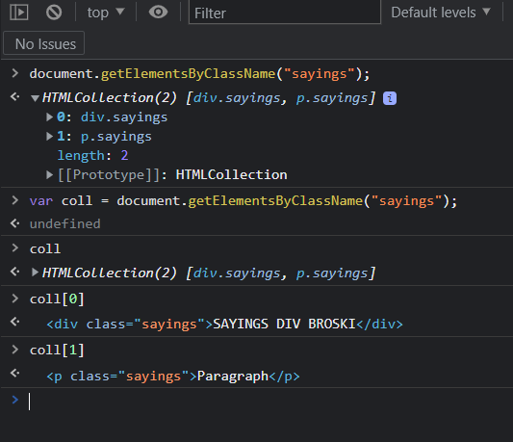
You can even do the same with tags and search the array/collection with its index. eg: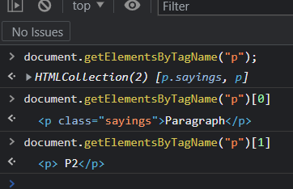

3 Ways to search for things in consoles:

document.getElementById(“id”)
document.getElementsByClassName(“className”)
document.getElementsByTagName(“tagName”)

You can even change HTML by doing .innerHTML at the end of the command: (!PERMANENT)
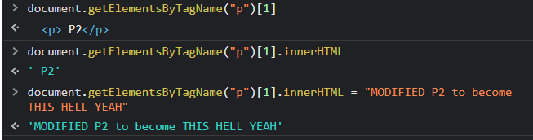

Getters & Setters and can modify / add styles with JS → document.getElementsByTagName(“body”)[0].setAttribute(“style”,”background-color:red”)

***MIDTERM: NEXT WEDNESDAY***
2023-02-02:

JavaScript identifiers: camelCase and should be descriptive such as sum, age, appleCount. $ and _ are allowed to be used in the name but in his class, he forbids it.

myVeryCuteVariable != myvercutevariable → according to JS, these are TWO different variables → it cares about uppercase & lowercase

Since everything is var, we could use “” (used for strings) and ‘’(used for chars) in place of each other
Arrays can be defined with square brackets:
var cars = [“Saab”, “Volvo”, “BMO”];

var: public
let: private

Modulus (%): eg (13%5=3) because it gives remainder, 5 fits twice in 13 so 13 - 5*2 and so the remainder is 3

letters.substring(5,6) is like [5,6[ //6 isn't part of group
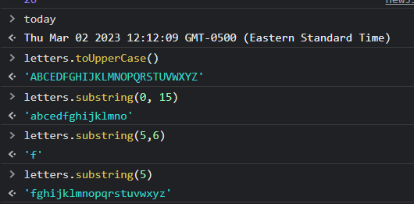

No such thing as int, long, float, double, JS has only one data type → numbers, only numbers

The date object takes the time from the local machines clock

Timestamp as a number: 1460656193939 (amount of milliseconds that have passed since January 1st 1970)
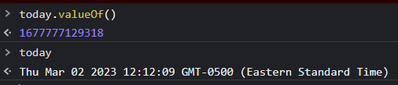
The month in a date object is stored in an array so if you want the second month, you write the 1st
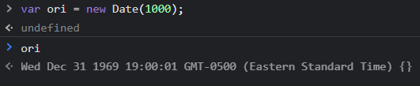

Default is 01 days and 00 month so january 1st of month

5==”5”
True
JS doesnt care about type so much that an int and string are equal
“==” : value
!= : not equal value
5===”5”
False
The triple equal now cares about types
“===” : value & type
!== : not equal value and not equal type

Javascript doesn’t care about fixe size in arrays
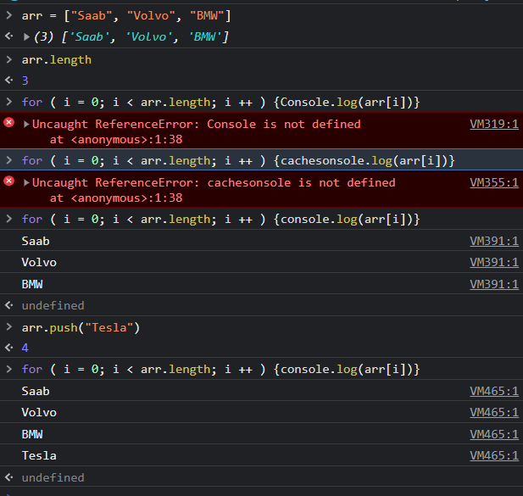
It should be for (var i = 0; [..]) dont follow bad habits
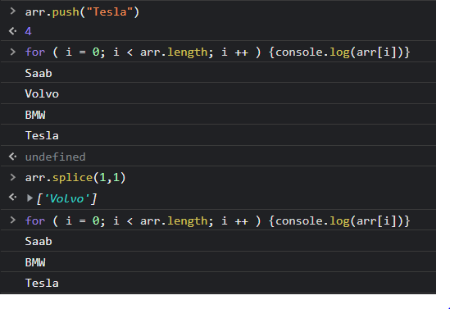
0 → false → nothing
1 → true → anything else
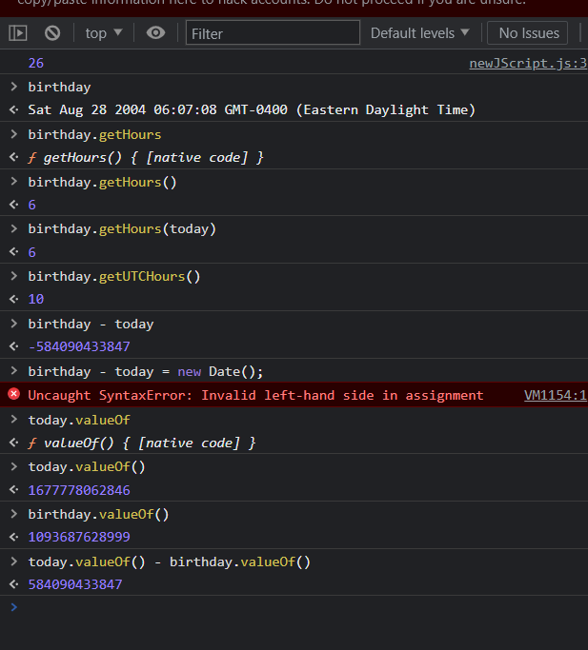

Element in HTML 5: <canva id = “myCanvas”> </canvas>

Canvass

Regular Expressions: RegEx is case sensitive: j != J
Meta-Characters: \d → represents any digit (number) from 0-9
\d\d → represents any pair of two numbers from 0-9

EG: Detect a valid phone number through this: \d\d\d-\d\d\d-\d\d\d\d

\w → represents any character that can be used in a word (not case sensitive)
\w: letters, numbers and ‘_’ (underscore)

. : wildcard that means everything and not the literal character dot

\. : this will do the literal dot characters

EG: Detect a valid gmail address: .@gmail\.com
EG: Detect a valid any type of email address (worse): .@.\....

[abc] : only allowing character a, b and c, & a, b, c are the only characters permitted

EG: Detect a valid any type of email address (better): .@.\.[cmo][cmo][cmo]

[^abc] : same thing as above except the ^ means not, every character is permitted EXCEPT a, b, c

[a-z] : allows every character starting from a and ends in z, it’s a range of characters(only lowercase)

[a-zA-z] : allows every character starting from a and ends in z and from A to Z, it’s a range of characters(lowercase & uppercase = any letter)

[a-zA-Z0-9] : allows every character starting from a and ends in z and from A to Z and a number from 0-9, it’s a range of characters(lowercase & uppercase = any letter)

EG: Make a RegEx that does the same thing as \w: [A-Za-z0-9_]

\d{3} : means the number inside will be applied to the special character that precedes it in a loop → this means \d\d\d

\d{2,3}: repeats it at minimum 2 times but at max 3
\d{2,}: repeats it at minimum 2 times so 2 times and up 2+

EG: Detect a valid phone number through this that cannot start with 0 or 1: [2-9]\d{2}-\d{3}-\d{-4}
EG: Detect a valid any type of email address : .@.\.[camo]{2,3}

-------------------------------------------------------------------------------------------------------------------------------
REVIEW
-------------------------------------------------------------------------------------------------------------------------------
\w : letters, numbers, “_” (underscore)
\d : digits (numbers from 0-9)
. : wildcard (everything) (it’s a dot)
\. : actual dot (.) character
[abc] : only allowing character a, b and c, & a, b, c are the only characters permitted
[^abc] : same thing as above except the ^ means not, every character is permitted EXCEPT a, b, c
[a-z] : allows every character starting from a and ends in z, it’s a range of characters (only lowercase)
[a-zA-z] : allows every character starting from a and ends in z and from A to Z, it’s a range of characters(lowercase & uppercase = any letter)
[a-zA-Z0-9] : allows every character starting from a and ends in z and from A to Z and a number from 0-9, it’s a range of characters(lowercase & uppercase = any letter)
\d{3} : means the number inside will be applied to the special character that precedes it in a loop → this means \d\d\d
-------------------------------------------------------------------------------------------------------------------------------

KLEENE CHARACTERS: (represent uncertainty and vagueness)
-KLEENE PLUS (\d+) it means previous character will appear 1 or more times (a+ = “a” or “aaaaaaaaaaaaaaaaaaaaaa”)
-KLEENE STAR (\d*) it means previous character will appear 0 or more times (a* = “ “ or “a” or “aaaaaaaaaaaaaaaaaaaaaa”)

? = means optional in a range of [0,1]
EG: [ ]{0,1} == [ ]?

ab?c = abc or ac
[abc] = “ “ or “a” or “b” or “c”

What? = What\?
^What = anything that starts with What
What$ = anything that ends with What
^What$ = just the word What

\s = represents any type of whitespace like space, tab or new line{\n)
^ = if u put the hat at the beginning of the beginning of the regex is saying from the beginning of the line, its the start of the line (has to start with)
$ = at the end means end of line (has to end with)

^[(]?[2-9]\d{2}[)]?[ -]?\d{3}[ -]?\d{4}$= for phone numbers

^Wh[oaey][tnr]?[e]? = regex for Who What When Where Why → WRONG BECAUSE IT CAN ACCEPT “Whete”

| or operator
^(Who|What|When|Where|Why)[\w\s,]+\. → finds every sentence that starts with any of the 5 Ws
^[a-zA-z0-9]{2,}@[a-zA-z]{5}\.[com|ca|org]$ → for emails

CONSOLE:

const paragraph = “The quick brown fox jumps over the lazy dog. It barked.”
→undefined
const regex = /[A-Z]/g; // the expression in between / / is for the system to recognize its a regex and g is for global and will not mess your regex up
–undefined
const found = paragraph.match(regex);
→undefined
found
→ (2) [‘T’,’I’]
found2 = paragraph.match(regex);
→ null //means no match found

var fname = document.getElementbyId(“fname”).value
→undefined
fname
→ ‘Ronald’
var reg = /^[A-Z][a-z\-]{2,10}$/g
→undefined
fname.match(reg)
→[‘Ronald’]

Filtering Criteria : REGEX:
Fname: ^[A-Z][a-z\-]{2,12}$
Name: ^[A-Z][a-z\-]{2,12}$
Password: ^(?=.*[A-Z])(?=.*\d{2})[A-Za-z\d\!\.\?]{6,24}$
Username: ^[A-Za-z\d\_\.]{6,16}$
EMAIL: ^[a-zA-Z\d][a-zA-Z\d\_\-\.]{3,15}@[a-zA-Z][a-zA-Z\d\-\.]{0,22}[a-zA-Z]\.(com|ca|qc)$
-------------------------------------------------------------------------------------------------------------------------------
Reg.Exp.prototype,match() = array
Reg.Exp.prototype.exec() = array
ALWAYS USE →
Reg.Exp.prototype.test() = boolean
-------------------------------------------------------------------------------------------------------------------------------

The Internet & Privacy of Information

WAN( Wide Area Network): BIGGER → Internet is the biggest WAN
LAN( Local Area Network): SMALLER → Vanier

Brute Forcing: guessing until you get the right password
SQL Injecting: ‘Ronald’ or 1==1 --
Social Engineering: Ronald,01,Saint-Laurent,1973

2023-04-12:

XML:

<br/> == <br></br>

EG:
<?xml version="1.0" encoding="UTF-8"?>
<information>

<card>
<profession>Student</profession>
<name first = "Ariel" last = "Wazana"></name>
<location>
<adress>5879 Avenue Kellert</adress>
<city>Cote-Saint-Luc</city>
<province>Quebec</province>
<country>Canada</country>
</location>
</card>

<card>
<profession>Dog</profession>
<name first = "Coco" last = "Wazana"></name>
<location>
<adress>5879 Avenue Kellert</adress>
<city>Cote-Saint-Luc</city>
<province>Quebec</province>
<country>Canada</country>
</location>
</card>

<!-- They are multiple cards so I guess you can call it an array of cards. -->

</information>

XML is used for storing data but HTML is used for showcasing data. XML is used only in legacy web, not in new websites (they all used .json for 20 years).

XML is passive. It doesn’t actually do anything, it’s just there to store data in ways that both parties know what it does.

XML is case sensitive and must be properly embedded. XML will flag things that are mistakes unlike HTML.

XML & HTML have entities for any special symbol you may need.

JSON:

JSON = Java Script Object Notation
Object Notation in JavaScript is what it’s based on, here's an eg (In JS):
var card = {
profession: "Student",
firstName: "Ariel",
lastName: "Wazana",
location: {
address: "5879 Avenue Kellert",
city: "Cote-Saint-Luc",
province: "Quebec",
country: "Canada"
}
}

Object Notation in Array in JSON, here's an eg (In .json):
[
{"profession":"Student", "firstName": "Ariel","lastName": "Wazana","location": {"address": "5879 Avenue Kellert","city": "Cote-Saint-Luc","province": "Quebec","country": "Canada"}},

{"profession":"Dog", "firstName": "Coco","lastName": "Wazana","location": {"address": "5879 Avenue Kellert","city": "Cote-Saint-Luc","province": "Quebec","country": "Canada"}}
]

JSON Class in Console with JSON.stringify method:
JSON.stringify(varName) is a method that transfers an object in JS to string of the JSON code:
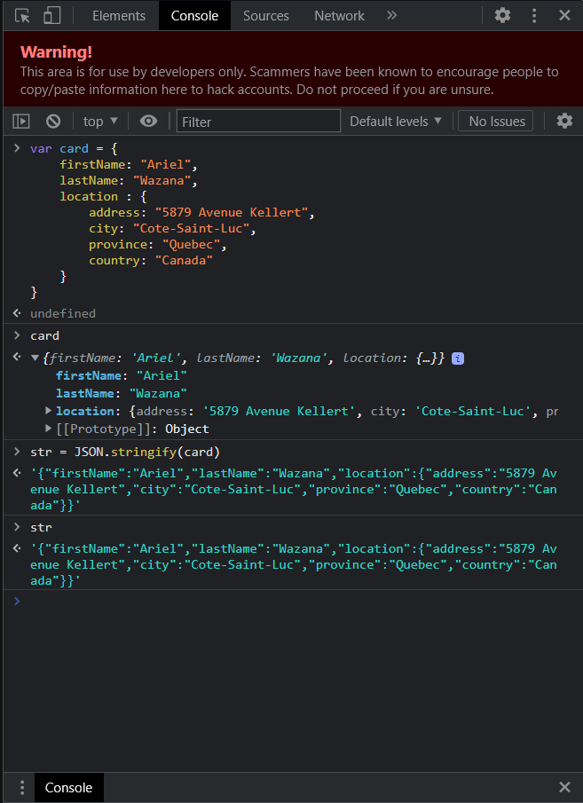

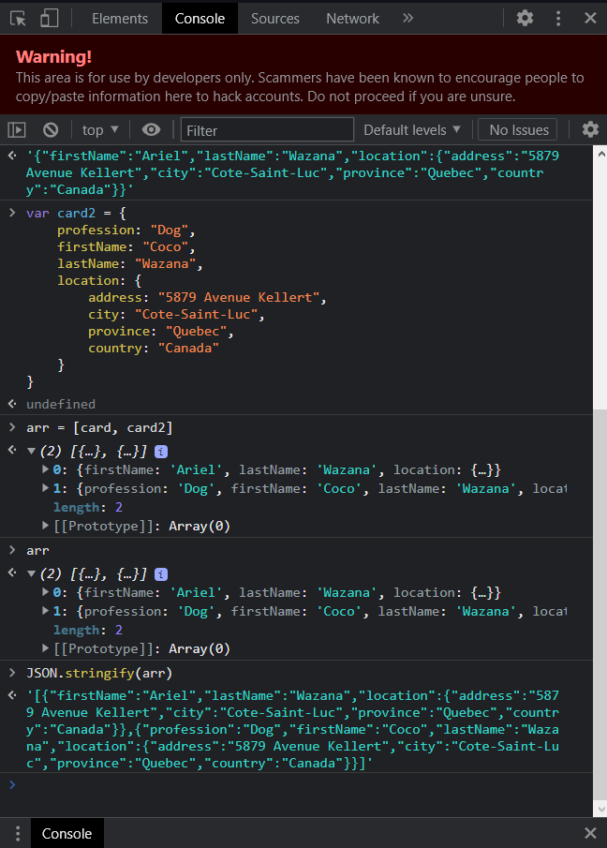

JSON Class in Console with JSON.parse method:
JSON.stringify(varName) is a method that does the opposite of stringify and it turns a JSON string into a JS object:

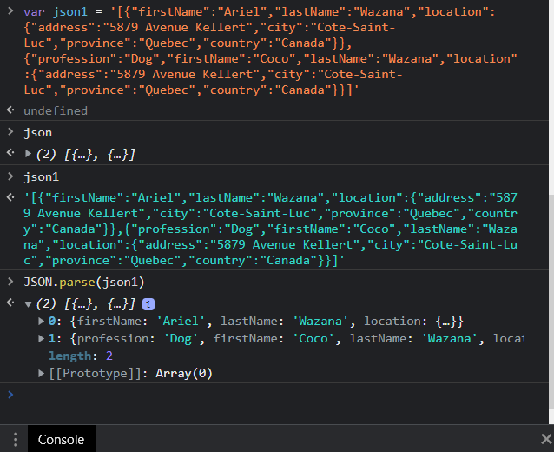

2023-04-13:

COOKIES:

document.cookie = “your cookie”

Most popular Webserver = “Apache Web Server”

Localhost → xamp apache
http://localhost/cookies.html.txt
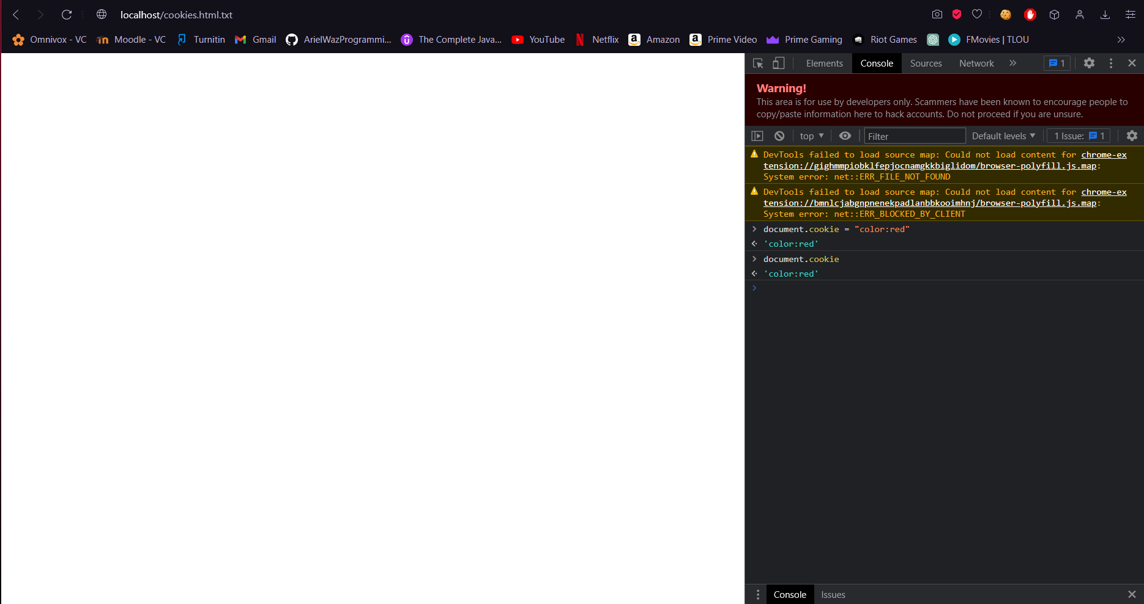

JQUERY:

In JS, the root of everything is the “document” but in JQUERY it’s “$”. JQUERY library allows us to “write less. Do more”.

JS: document.getElementById(‘first’).value;
JQUERY: $(‘#first’).val();

JS: var arr = document.getElementByTagName(‘input’);
for (int i = 0; i < arr.length; i++){
Arr[i].value = 123;
}

JQUERY: $(‘input).val(123);

SELECTORS:
$(‘#first’) = CSS ID SELECTOR IS #
$(‘.apple’) = CSS CLASS SELECTOR IS . an class name is apple
$(‘input’) = CSS SELECTOR FOR ALL ELEMENTS BY TAG NAME input is input

https://jquery.com
https://developers.google.com/speed/libraries#jquery
<script src="https://ajax.googleapis.com/ajax/libs/jquery/3.6.4/jquery.min.js"></script>

BASIC SYNTAX: $(selector).action()
Anonymous Function: Function without name = function(){}

$(document).ready(); //When the document is ready (Wait until page finished loading) same as onload
$(document).ready(function(){
$("input[type=password]").hide();
});
The content inside Open and closed brackets used to access is called InnerHTML. JQuery also has InnerHTML.

200: Successful
404: Page not found

